**Gravity and Riemann Hypothesis**

The reason why this article does not involve mathematical formulas is that the author 's mathematical ability is limited, and the article only has enlightening effect.

The article is all theoretical arguments, no experimental data.

Author: Shi Jun Ze

The independent author is from Hebei Institute of Engineering and Technology in China

Email: [15003615276@163.com](mailto:15003615276@163.com) Phone: 15003615276

**Abstract**

Inspired by the author 's Riemann conjecture, this paper attempts to solve the contradiction between four dimensional spacetime and quantum mechanics in physics. Guided by Euler 's identity, two important ideas of collision and vibration are introduced.

The document deeply discusses the relationship between substance dimension and energy, including the stability and change of dimension, the relationship between energy and substance, the relationship between time and dimension and so on. Through detailed assumptions and explanations, this paper provides a new perspective for us to understand the complexity of the substance world.

It mainly introduces how substances of different dimensions interact, the generation and transformation of energy, and the influence of dimensional changes on substances. The following is a summary of the core content of the paper :substance dimension and energy, the influence of dimension change, the stability and change of dimension, the relationship between gravitational field and dimension, time and dimension, and the realization of dimension change.

**Keywords:**gravitation; Riemann hypothesis; Euler 's identity; collision; vibration

**1 Introduction: Research direction of gravity**

It is easy to recall the geometric structure of general relativity when discussing gravity. Relativity interprets gravity as the result of spatial bending ( four-dimensional space-time ). That is to say, the essence of gravity is the change of time and space, and quantum theory attributes all energy to quantum substanceizable substance. First of all, we should know that gravity and other substances should belong to energy. Energy requires space and time in the composition of substance, so we can understand that the two theories can be unified. Then think about why it 's so difficult. I adhere to the generalized relative view of time and space, and also insist that gravity is indeed an energy or force. I think solving this problem needs to find a theory that can accommodate two kinds of ideas.

**2 Shape of Space**

According to Einstein 's theory, energy can distort space [ 1 ].In the process of spatial distortion, a curved velocity change is formed. Then consider whether gravitational wave is gravitational wave : if there is no scientific theory that gravitational wave is other substance wave, then gravitational wave is gravitation.

Next, we think about the special relativity of speed. Because the speed of light is constant, the space will change. Now go back to the microscopic world and think about how quantum conforms to this behavior. If quantum conforms to gravity, why gravity can only be a gravitational wave state, not a particle state.

Thinking process one : speed changes the motion space, then whether the quantum has its own space can balance the changed motion space. Self-space is a strange concept. We have never thought that a substance has its own space in addition to its own volume.

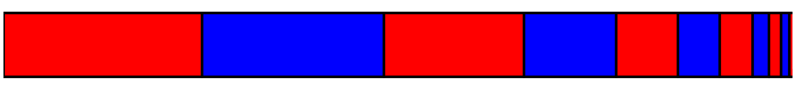

Figure 1

Thinking process 2 : Two clocks with different speeds will deviate under observation, which seems to be the time affected by speed, but I think it is speed that changes space, and space changes time. If the substance has its own space, then there will be a special situation that allows the substance to produce its own time. This situation must occur within its own space and be related to the length of its own space. Two kinds of space are introduced : one is the compressed space, and the other is the stretched space ( for this reason, I will use the physical meaning of Riemann 's conjecture to explain ). The compressed space is similar to the substance we can observe, but both spaces belong to the substance space, so the compressed and stretched spaces are intertwined. These two forms of energy constitute the three-dimensional properties of substance : positive energy and negative energy.

# **3 The constant speed of light brings us ideas**

Thinking process 3 :As stated in special relativity, the constancy of the speed of light means that no substance how fast the observer moves, the speed of light measured by the observer remains constant. However, the speed of light will not change under different reference frames. I think the key is that photons are limited in a certain range. Or the photon has been out of this range ( that is, unaffected or unable to balance the observer ). Lorentz transformation is not a way to keep the speed of light constant but to get photons out of this range ( similar to the way to realize the ideal world from the perspective of God ). We mentioned before that space is composed of positive energy and negative energy, so photons may have the same positive energy and negative energy at the same time.

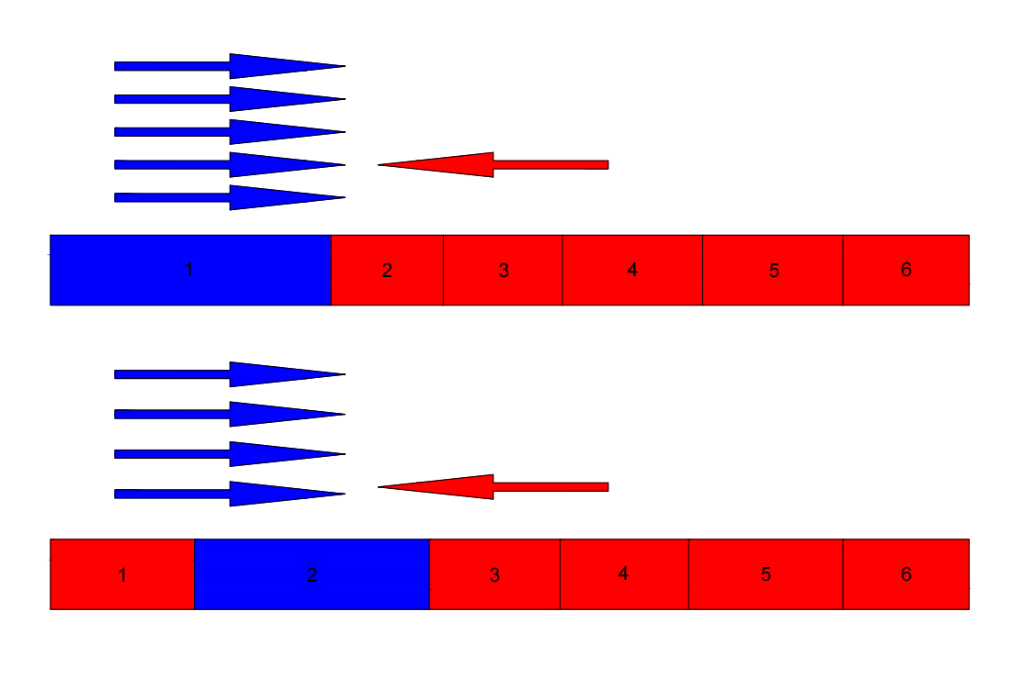

Figure 2

According to De Broglie 's theory, moving objects produce phase waves. However, these phase waves can reach faster speeds than light. In other words, the phase wave has energy but the speed exceeds the speed of light, and it can be inferred that the phase wave does not have substance properties. From this we can know that energy and substance are not exactly equal. However, it is the energy wave generated by substance, so we speculate that the dimension of substance change is closely related to the phase wave. We explore the significance of phase wave velocity c * 2 / v.

The velocity represents the spatial variation in the transmission velocity. In the overall space, the shape of space is constantly changing. Throughout this process, the spatial variation can still be transmitted at a speed of c*2. Therefore, in the c*2 inference process, a moving object is constantly transmitting a deceleration signal v into space. Due to the constant changes in space, this value decreases to c*2/v.

$\frac{c^{2}}{v}$ ×v=Spatial transfer velocity

The speed of photons moving in any space is equal to the speed of photons transmitting in space. Photons always move in a constant space. Once the speed of photons is greater than the speed of space transmission, the speed of photons will slow down, so that the speed of photons is at most equal to the speed of space transmission. That is to say, for a dimension, the maximum speed can only be the speed of light. This also means that if a substance is moving at the speed of light, if it doesn 't stop moving, then its own space may be close to infinity ( it can 't generate new dimensions ). For the speed of light or space transmission speed, this quantitative may be related to a certain energy and does not have physical significance.

$$v<\frac{c^{2}}{v}$$

Energy is not limited by volume. On the contrary, it can be understood as a collision point, which creates a spatial configuration . The energy body vibrates continuously in a small range, forming a unit space size . Around this point, the force unfolds the space one by one（There is also a large overall space before there is no vibration.） The stretched space is negative energy, but this stretched space seems to be smaller than the compressed space. This leads to an overall display of attraction in one dimension. There may be an additional energy : zero collision. If there is no zero energy, the contrast between positive and negative energy will gradually disappear, so the substance will continue to have positive and negative energy, but zero energy is the positive and negative energy after splitting. and finally regenerate new dimensions. If there is no new dimension, then the universe itself will not return to the starting point.

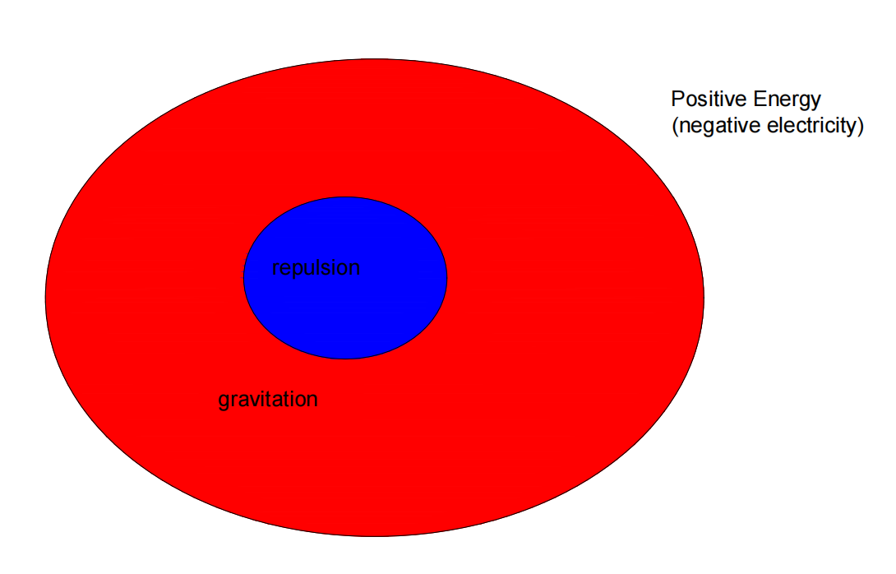

Figure 3

**4 Positive and negative**

There are two conclusions : positive and negative. Thinking process 4 : Energy can be divided into positive energy, negative energy and massless energy. The negative energy is also affected by the acceleration of gravity. When it enters the gravity field, the greater the difference in the direction of gravity, the greater the difference. Therefore, the gravitational field of space will be more compressed, thus accelerating this process. This acceleration has the same order of magnitude as the positive energy.

The key to expansion is zero energy, which is progressive in dimension ( energy quantity ). The essence is that although the negative energy has been increasing, with the increase of zero energy ( new dimension energy ), the substance will still expand. So for a rising dimension of the substance, is always more positive energy. As the dimension increases, the negative energy will be infinitely close to the positive energy until the gap between the positive energy and the negative energy is opened again after entering the next dimension. The energy of the next dimension can only be zero to achieve this effect.

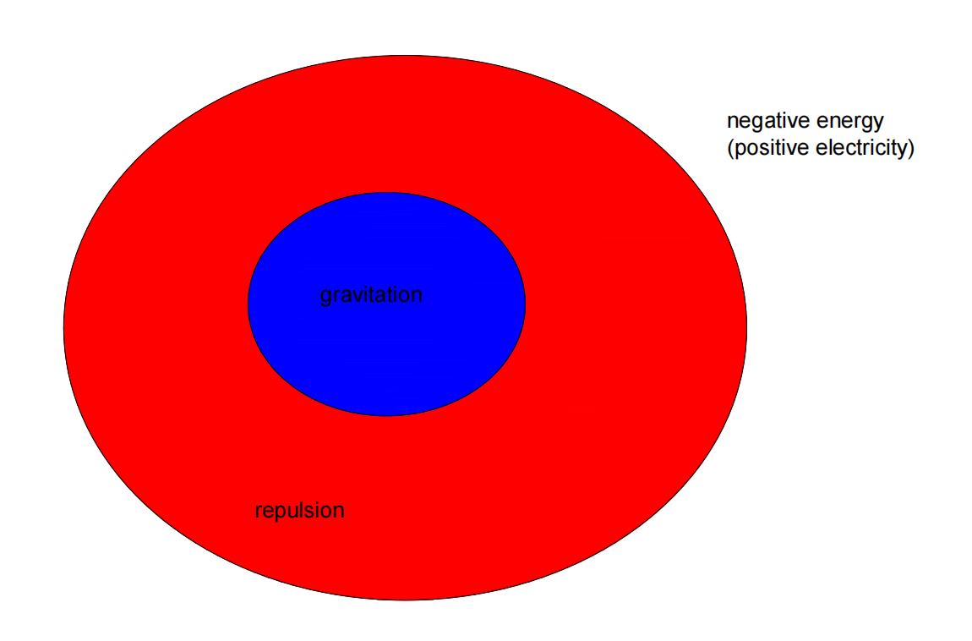

Figure 4

# **5 Explain why the superposition state is generated without changing the dimension**

Explore whether the incident angle has an effect on the particle entering the slit : if the particle has its own space, then the particle 's own space includes the surrounding negative energy space. Since the slit is similar to the wall, it will affect the collision inside the energy ( the specific reason needs to be understood later ). Once the collision inside the energy is affected, the energy will increase or decrease the dimension. The specific dimension or dimension reduction needs to take into account the incident angle and the collision direction within the energy ( three-dimensional four-dimensional needs about countless collision directions ).

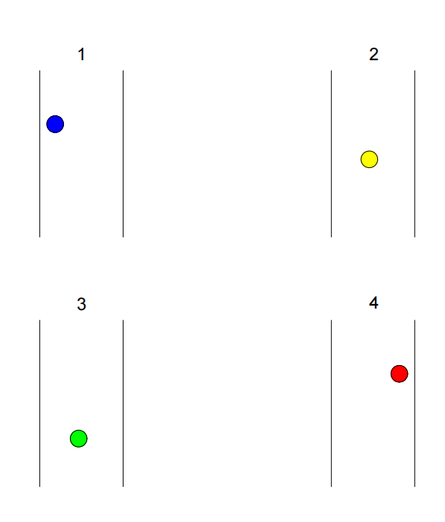

Figure 5

**6 Observers and randomness**

In the case of a slight deviation in the exact position of the particles entering the slit, the space around the particles will change significantly. Similar to the intersection of electromagnetic fields, an asymmetric space is formed. Different incident positions will lead to different staggered spacing. Different staggered spacing can produce different positive and negative poles. The positive and negative poles determine the dimension change, and the dimension determines the substance form. The ascending dimension may show the wave state, and the descending dimension may show the particle state. ( The superposition state is not a substance form, and the particle state and the wave state may exist at the same time for a substance, which will be balanced in the later dimensions. )

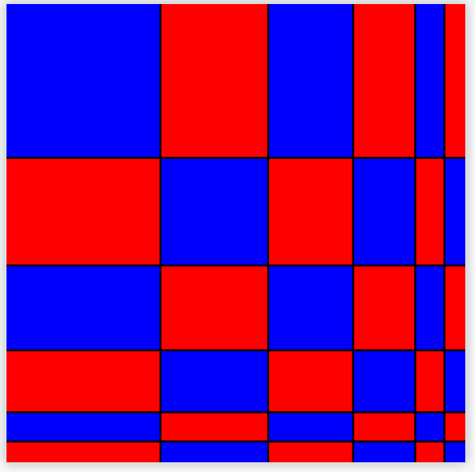

Figure 6

If the form of substance is related to the dimensionality, the original dimensionality of substance will change slightly after entering the slit, and the change is the non-integer dimensionality behind.

At this time, the total dimension of the object only changes slightly, which can be regarded as the dimension unchanged. But why there is randomness or wave-particle duality or superposition state or path integral. Because there is a dimensional balance ( partial dimension increase and partial dimension reduction ) within the substance, but the total substance has only one result at this time. Observing this behavior is similar to helping two substances become a whole, 1 If there is no observation behavior ( interaction ), the two energies can be considered as two small wholes in a large whole. 2 But as long as the mutual influence of the two energy will become a substance, that is, into a small whole. But the process of 2 is very slow, but it can be considered to promote the balance of dimensions. 1 is to prevent the dimension balance, only with the help of a larger overall dimension balance. Dimension balance is very important. The following will be introduced. If there is no dimension balance, the positive and negative energy will be completely distinguished. For example, another person who comes face to face will not be embarrassed if he does not observe. As long as one of them observes another person, the observed person will be unconsciously uncomfortable.

**7 Guess the black hole**

Each photon occupies a discrete space unit, and the photon is very close to the integer dimension. The black hole can be considered as the precursor of substance, and Any energy entering the black hole will be dimensionally balanced with the black hole, thereby reducing the dimension. The black hole may be a two-dimensional surface close to three-dimensional substance, which is in the same position as photons（Photon is one dimension higher）.

**8 Collisions produce**

There is only one possibility for the production and opposition of positive and negative energy. Before the beginning of time, there is a zero-dimensional point in each unit space, and there are infinite unit spaces in the universe.

It is assumed that the universe begins at infinitely many zero-dimensional points in an infinite dimensional space(The infinite dimensional space here refers to the number of vibration directions of a whole.). The universe began as a single point of sudden vibration. Since the surrounding point is stationary, the vibration point will collide with the surrounding point elastically, causing the vibration of the surrounding point and propagating the collision to the surrounding point. As a result of these collisions, the central point and the surrounding points form the same collision frequency ( although the universe is infinite but there are always boundaries ). As the collision continues, the first momentum will disperse. Until the total momentum in one direction is zero, but there will still be a weak residual energy that can be gathered again to one of the points ( which is already the point on one-dimensional substance ). New vibrations occur ( in different directions ). Until the new dimension is generated again, but the new collision energy is very weak, so the higher the dimension, the smaller the substance.

**9 The necessity of mathematics**

When the center point suddenly vibrates, there will be a positive direction. Suppose that a square ( or any other figure ) is filled with countless points, without any gaps. When the center point vibrates, the resulting collision will propagate around. Because the collision is certainly not infinite, it will stop after the energy reaches zero or a closed loop is generated. But the remaining energy will collide again to produce a higher dimension. After a certain period of time, the vibration mode evolves,, which drives the vibration of the surrounding points. There are countless points in the surrounding space, similar to walls, allowing for fully elastic collisions. The unit space can also be the space formed after the collision is stable, but the universe must be filled with countless zero-dimensional points on average at the beginning. After a point vibrates back and forth, it shows two very different trends : forward movement and backward movement. Both trends are multiples of π Figure 7. And the two trends are the vibration of a substance. The collision of two directions can produce two ways of dimension change, one is to promote dimension change, and the other is to prevent dimension change. The first direction is to promote the dimension increase ( expansion ), and the rebound direction is to prevent the dimension increase ( contraction ) by reducing the dimension, similar to Figure 2. Due to the decrease of momentum consumption and collision frequency, the positive vibration is greater than the negative vibration.

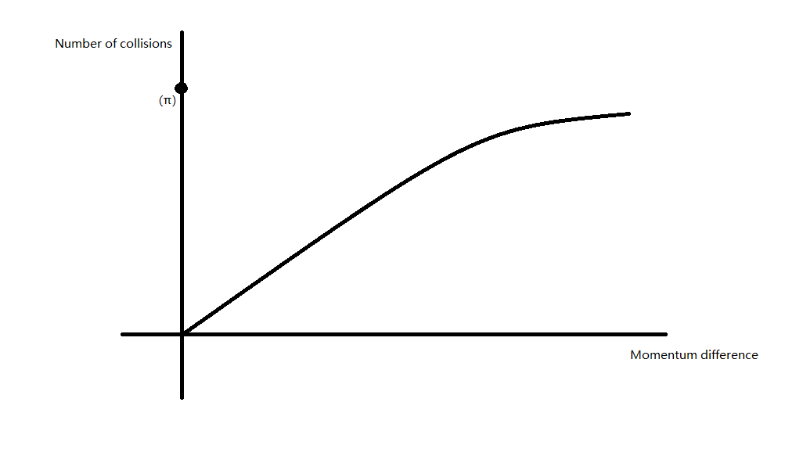

Figure 7

**10 Conjecture**

The substance is controlled by stratification, in which the point vibrates into a line, the line vibrates into a plane, the plane vibrates into a ball, and so on.

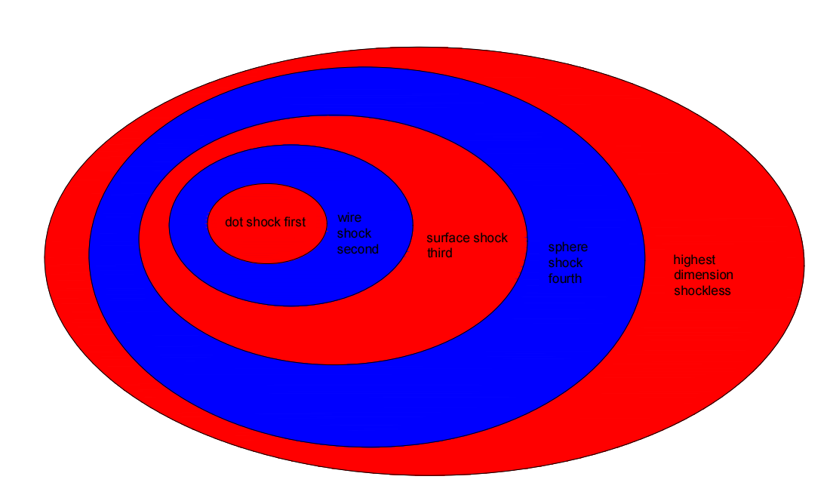

Figure 8

**11 The inspiration of mathematical logic given by Riemann conjecture**

We first consider the big whole: based on the previous statement, π is related to the number of collisions; Then analyze the collision unit. Note that e, (1+1/n) *n; this formula is the base number of energy transmission( also the focus ). And the imaginary number i is the direction of a dimensionality generated by collision in the presence of one dimensionality.

e * i is equivalent to the process of passing to this new dimension ( each vibration brings a new direction of collision ). This length can also be considered as the process of energy dimension increasing. That is to say, each new dimension addition is equivalent to the 0 energy of the previous dimension ; of course, 0 is an approximation.

The formation process of the new dimension is similar to the calculation process of the bank 's compound interest. A straight line collides with a plane composed of n straight lines ( or elastic collision with the wall ). Let V1 denote the velocity of the line and V2 denote the velocity of the line in the plane.

$$\frac{1}{2}M{V1}^{2}=\frac{1}{2}nM{V2}^{2}$$

$$\frac{1}{n}{V1}^{2}={V2}^{2}$$

This formula shows that : with this formula we understand the physical meaning of e.Suppose that there is a straight line which is an entire one-dimensional substance and there are countless zero-dimensional points in space. At this time, the straight line has a collision residual energy, which can only be concentrated on a quantum in the straight line. This energy causes the quantum to collide for the first time ( a collision here describes an integer ten times the number of π ). At this time, the quantum collision to the wall will undergo an elastic collision( wall refers to countless zero-dimensional points ) . The energy of the wall rebound is excited to all the quantum on the straight line, and a collision residual energy is still generated and concentrated into a quantum, but the next collision wall not only includes this quantum but also includes the n-dimensional substance generated by the first collision ( this formula is similar to the 1.000001 dimension ). So the second bounce will have an energy dispersed into all the quantum again to make this straight line into 1.000002 dimensions. This process needs to last for countless times, the collision residual energy is similar, and the number of times of this process is similar to the n-th power. Here n is not a number but it is infinite. Therefore, the process of one integer dimension ascending to another integer dimension is similar to that of bank compound interest, but each collision of individual quantum is π times, and each collision is similar to a new collision direction i. Finally, the negative energy with the same energy can be generated to offset the positive energy brought by the residual energy of the first collision. Form an integer dimension substance. Explain that the Euler 's identity is only applicable to the large whole, and it is an energy cycle, not a substance cycle. With the change of dimension, substance is changed. 1 in the Euler identity is the initial collision residual energy, that is, the difference between positive and negative energy at the beginning. Result-1 is the increment of negative energy after rising an integer dimension. The imaginary number i indicates that the newly added collision direction is based on the original vibration direction.

**The Riemann conjecture: 1+1/2*s+1/3*s+1/4*s......[6]**

Let 's understand the new dimension from a different perspective. Let us say that we start with a point with mass 1 and velocity V1. The velocity of each point after n passes is set to V2.

$$\frac{1}{2}M{V1}^{2}=\frac{1}{2}M\left({V2}^{2}+{V2}^{2}+{V2}^{2}+⋯\right)$$

$$\frac{1}{2}M{V1}^{2}=\frac{1}{2}Mn{V2}^{2}$$

$${\frac{1}{n}}^{\frac{1}{2}}V1=V$$

We exchange energy for speed, or we separate each collision ( here the collision is also refers to the π of the whole tens of times ), here refers to the speed added until can 't produce acceleration. Because the positive energy is equivalent to acceleration, and the negative energy is equivalent to deceleration, as long as the deceleration is equal to acceleration, the material can not produce acceleration in another direction. It can not be raised again. At this time, the only way to upgrade the dimension is through external means. The Riemann conjecture expresses the residual velocity of the collision that can be generated after each dimension increase ( the velocity loss may also be related to the energy loss generated by the finite zero-dimensional point in the universe ). The most important part of this formula is the imaginary part, which is related to the dimension of the previous integer that collided. Different integer dimensions have different speeds of improving dimensions, because integer dimensions have different vibration times. As long as the zero-dimensional point vibrates in space, there is a slight energy loss or there is an impact between energy movement and space, the next dimension can be imaged. The higher the dimension, the less likely the material is to improve the dimension. Therefore, increasing the speed is also a way to improve the dimension, but the higher the integer dimension, the more difficult it is to improve the dimension ). The direction of vibration is generally determined by the dimensional balance ( energy balance ) in the large whole.

The law of energy transfer can be realized only when the real part satisfies 1 / 2. The Riemann conjecture is related to the energy in the new dimension ( although describing the speed change but more intuitively how to generate a new integer dimension ), and the Euler 's identity is related to the position of the current dimension ( although describing the large overall energy but more intuitively the motion of the ascending dimension ).

Whether π is an irrational number depends on the dimension. The lower the dimension, the closer the number of collisions is to π. This expression will make us think that the energy in the final universe is an infinite dimension. When the particles reach the infinite dimension, the remaining energy of the collision will gather again and a new excitation will occur, but the infinite dimension at this time is equivalent to zero dimension.

The basic law of is not complex ( running direction ), but complex is the balance of dimensions in the whole and the direction of vibration caused by the balance of dimensions. Therefore, the basic force and the basic particles are complex intermediate processes ( operation mode ).

Although the vibration direction of the small whole in the large whole is very different, in general, we can think of it as a similar vibration direction.

**12 Understanding dimension**

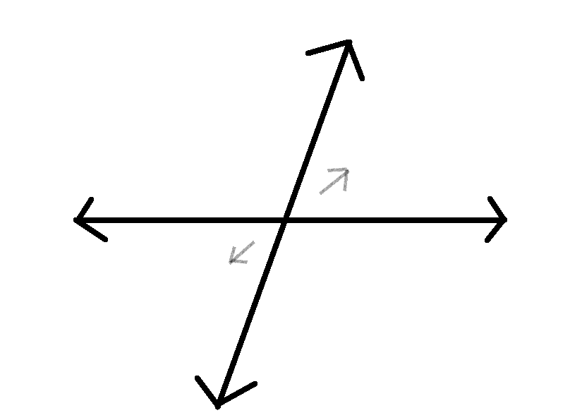

Figure 9

The vibration of two-dimensional substance in space will produce two directions of motion. The original integer dimensionality determines the complex part in the Riemann hypothesis. Only one imaginary number i can exist because the substance can only add a new direction of vibration at a time, even if the substance disperses the vibration, the substance can only increase the dimension or reduce the dimension at a time.

Substances of the same dimensionality must be the same（Do not consider the internal）, and the direction in which any substance vibrates to a new dimension is fixed. Different dimensions combine to form a new dimension, such as 2.1 + 2.3 = 2.2, but the newly generated high dimension is not easy to be generated by the original single dimension, for example, 2.23 only produces 2.2 ( this process is too slow, the basic fast dimension change comes from the dimension balance ). 2.23 can affect the motion of 2.2, but this effect is minimal.

Although 2.2 has a significant impact on 2.23, due to the huge energy of the two-dimensionalityal vibration itself, it cannot directly change the vibration direction of 2.23. So 2.2 + 2.23 = 2.2...... 2.2 and 2.23 have the same vibration direction but are different types of substances. Due to the principle of collision, assuming the energy of three-dimensionalityal substance is 1, in the process of forming three-dimensionalityal substance, the energy of two-dimensionalityal substance is n times that of three-dimensionalityal substance, because the Riemann ζ function causes the new substance produced by the two-dimensional substance to be always an integer multiple of the entire three-dimensional substance.

Here only involves the whole idea, the specific process needs the help of modern physics.

A zero-dimensionalityal point vibrating into an infinite-dimensionalityal point will eventually come to a complete stop, until all points vibrate into infinite dimensionalitys without colliding. However, the imbalance of positive and negative energy will still exist, leading to vibration occurring again(The last collision can not release the original substance, but there is always residual energy).

Assuming the first two dimensionalitys of 2.2 and 2.3 have exactly the same vibration direction, these two substances can combine to form a new dimensionalityal substance. This new substance has a characteristic that it can exist as a single substance rather than a combination of two substances, at this point entanglement occurs(Dimension balance).

It is difficult to accurately raise the dimensionality from 2.19 to 2.2 in large quantities of producing a certain dimensionalityal energy. If we want more 2.2 energy, we need more 2.1 and 2.3, which means higher and lower dimensionalityal energies need to become more. This way, the probability of producing 2.2 will also increase. We need to know that when a certain dimensionalityal energy is abundant, its anti-energy will also be abundant.

For example, excessive energy, such as inflammation, can be reduced by lowering the dimension. The treatment of special diseases such as cancer is different from the treatment of inflammation. Cancer can be treated by rising dimensions. Due to the high dimension of cancer cells, improving the dimension can effectively control the harm of cancer cells. However, the process of overall dimension increase is irreversible, that is to say, cancer cells are not easy to reduce dimension. If we cannot find a way to reduce the dimension of cancer cells, we may be able to balance or slow down the speed of death by autonomous dimension reduction. You can improve your dimension by increasing positive energy or negative energy. Some viruses can also be treated in this way. With some inspiration, we can solve problems or diseases in life, such as paying attention or not thinking, like not using substance to reduce the dimension of substance, thinking about problems or using substance to increase the dimension, and changing the dimension can fundamentally change the substance.

However, any substance contains positive and negative energy, and a static substance mass is the negative and positive energy difference. As shown in Figure 9, the direction of the vibration represents the positive and negative energy, and the difference between the positive and negative energy determines the magnitude of the dimensionality, so the moment of the vibration represents the dimensionality of the substance at this moment. if the relativity of the frame of reference is not considered, the substance of the same dimensionality must be the same. That is to say, two substances of the same dimensionality have the same total positive and negative energy, but the direction of positive and negative energy vibration is different. Therefore, there will be different internal components for the same dimension. In addition, it should be noted that if it is a 3.4-dimensional substance and a 3.5-dimensional substance produced by the same whole, the first three dimensions of the two substances are not easily observed.

Next you need to think carefully. If the substance has vibrations in all directions, then the next dimensionality of the substance is easier to ascend but more difficult to reduce. Because the more the vibration direction of the substance, the easier it is to require energy in a specific direction. The process of raising the dimensionality can not avoid the collision to form a closed loop, so the promotion of the dimensionality requires collisions in all directions. Here, it refers to the combination of different dimensions or collision directions in a single dimension. A dimension refers to the collision in different directions that shakes the energy to zero, not a single vibration direction.

Next, we consider a special case where the velocity of the substance reaches the speed of light c. In the previous analysis, we know that the speed of motion reaching the speed of light is equivalent to time pause, and time is equivalent to the comparison of substance motion and space motion. Positive energy and negative energy are equivalent to shrinking space and stretching space. The substance reaching the speed of light can not produce space deformation, that is, can not occur relative collision, the positive and negative energy of this substance is equal. In general, this substance is an integer dimensionality substance.

There are four kinds of forces that are most easily observed in any dimensionality of substance. Assume that the dimensionality of a substance is 2.2, 2 dimensionality can produce a strong force, 0.2 can produce a weak force, the positive and negative energy difference between this substance and other substances can produce a force, the new dimensionality of this substance can produce a force. There is another force that is not easy to find, because the energy is too large and stable. This force is the previous dimensionality energy that 1 can generate. This force is a kind of balance force, because the positive energy of the former dimensionality must be equal to the negative energy and very strong, so this force can not be considered in life. It is assumed that there is no life on the earth, and there is water on the earth. In my understanding, the dimension of substance is related to the state of motion. The higher the dimension, the more complex the state of motion. The moon appears in the development of the earth, and the movement of the moon directly affects the complexity of the water source. With the influence of photons and water on electrons, the substance dimension is increasing. I think the residual energy of the collision is easier to gather to the higher dimension, because the energy is weaker and the energy is easier to obtain. However, it is not easy for us to judge the dimension of macroscopic materials, and there may be a big gap between the large whole with the same dimension due to the direction of vibration. But we can think that there is a complex dimension balance of the overall dimension is higher, rather than the material dimension similar to the overall. Because the matter we can observe is basically from a super-large whole. In this whole, the first part of the ascending dimension must carry out complex dimension balance. We know that the change of dimension depends on the alternation of positive energy and negative energy. If the positive energy and negative energy are basically balanced, it is difficult to change the dimension.

The most obvious vibration in the organs is the heart(The lowest dimension). Although the brain determines the complexity of the body. However, it is clear that the changes in the brain do not directly affect the organ but the movement behavior. This process is not as good as the impact of changes in the heart on the organ. After strenuous exercise, the biggest change is the heartbeat, here does not consider breathing changes in lung activity. Because body movement is a smaller dimension of ascension, it has the greatest impact on the lowest dimension. Similar to the sleep process, the weakly reduced dimension affects the brain(The highest dimension) the most. A slight effect during sleep may bring a slight increase in dimension. But after night falls, the human body ' s day of labor has reached the limit. If you do not go through sleep, the dimension of the body can not be reduced, and the greatest impact is also the brain. So some people like to think at night, because at this time the ability to think is stronger(Thinking reduces the dimension).

When two substances are close, the collision will not occur immediately. Because the substance itself does not exist in volume. This collision will produce high-dimensional substances and their reactions due to the proximity of substances. This high-dimensional particle is similar to a gluon. These processes will become more and more complex as the dimension increases.

The previous theory shows that the lower the dimension, the more stable the substance is, and the higher the dimension, the more complex the vibration and the smaller the energy.

The higher the dimension, the more the direction of substance vibration. Without external force, the complex vibration direction will make it difficult to reduce the dimension. The application of to people will lead to the usual always like to daze, and because of the direction of vibration, but the speed of response is slow, duration was longer, .

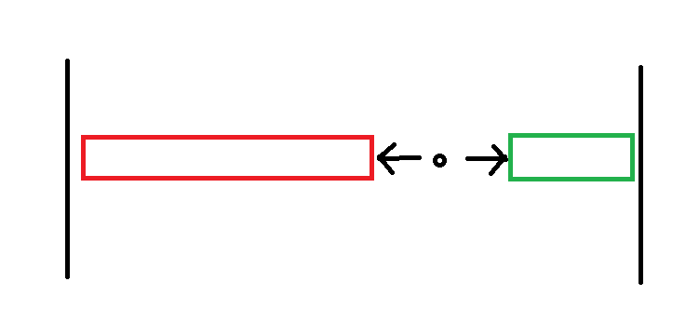

Figure 10

The principle of dimension balance is positive and negative energy balance. A substance 's short-term ascension dimension will be accompanied by the reduction of the surrounding substance dimension, because the positive energy of the substance is greater than the negative energy. Due to the balance, the negative energy of the surrounding substance will be greater than the positive energy.

When two substances with different vibration directions are together for a long time, the vibration direction and vibration trend of the two substances will become similar, because the long-term collision will produce the force to change the vibration direction. However, if the energy difference between the two substances is large, then the large energy will absorb the small energy. Because the high dimension around the large energy will react with the small energy substance.

Why is the positive energy greater than the negative energy. Here we regard the positive energy as a compressed space, and the negative energy is a stretched space. This is only a microscopic expression. For macroscopic substances, positive energy is only the result of positive and negative energy interlacing but positive energy is larger. The same is true of negative energy. When the compressed space is larger than the stretched space, the positive energy and the negative energy reach a balance after the collision, and the positive energy is equal to the negative energy. If we take the volume of substance as an example, it is better to understand, so positive energy greater than negative energy will rise in dimension.

The vibration direction of the previous dimension does not determine the vibration direction of the next dimension, but it can determine the change speed of the next vibration direction to the dimension, which is simply to determine the future vibration trend. This also determines the future state of motion of some substances, but this result is not necessarily only said to be a large probability. The collision in different directions is needed to increase the dimension.

According to Figure 10, we can see that positive energy and negative energy are generated at the same time, so the positive and negative energy should be completely symmetrical, but why the positive and negative energy in reality is not completely symmetrical, because only the deformation of space is used to approximately describe the force, but the essence of energy is the number of collisions. The number of collisions determines that the energy is not conserved. To eliminate the energy in one direction, we need the opposite direction and at least the same number of collisions to completely eliminate the energy.

Once again, we return to the quantum entanglement effect and discuss why the speed is infinite. What characteristics will be produced when two substances become one substance The space between two substances and the two substances can form a dimensional balance. Similar to two points colliding back and forth in a unit space, that is to say, two energies form a small whole, and attention must be paid to the fact that two must form one or few numbers, otherwise the balance of dimensions within the large whole can be neutralized by additional energy.

Although the higher-dimensional substance has low energy, it has a greater impact on the lower-dimensional substance. We know that the center vibration can lead to the surrounding dimension reduction. After the universe finally forms the highest dimension, there is no energy difference in substance. The dimension of the whole substance is exactly the same, similar to the disappearance of substance and energy, only the boundary（The reason for the boundary is that the last collision may be a positive energy collision. If it is a negative energy collision, there is no boundary, but this situation must exist in the whole） and the center point ( Since the whole is generally not an integer dimension, the central energy is slightly higher).

Figure.11 is a space generated by the collision path of the substance to approximately describe the volume of the substance.

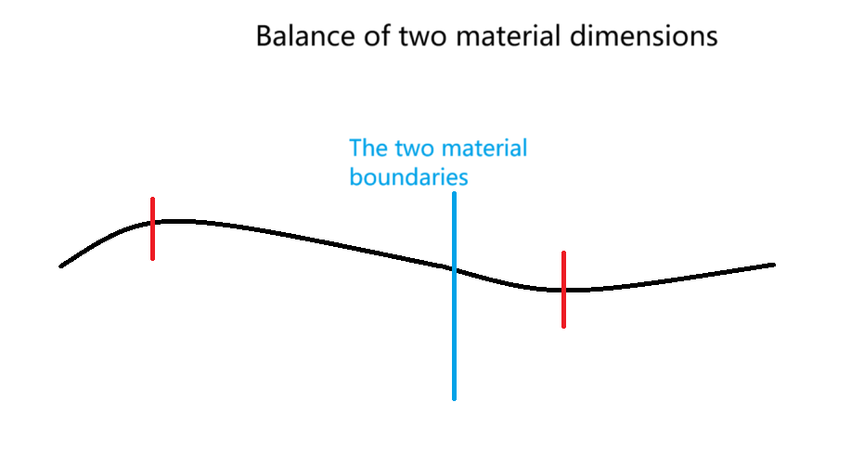

Figure 11

The annihilation between energies is because we only consider the existence of one form of energy in a substance. In reality, the energy form is a combination of positive energy and negative energy, because the high-dimensional space around the low-dimensional substance also requires vibration in two directions to form stability. This reaction is the annihilation of positive energy and negative energy, the total energy disappears, but both positive and negative energy still exist. Therefore, gravity is not negative energy, but the difference between the new dimension produced by positive energy and the new dimension produced by negative energy. Because positive energy is a compressed space. The new dimension is always more positive energy, so gravity is the resultant force of the new dimension. The reason why the size of gravity almost does not change is that the dimension of the big whole is difficult to change. Generally, the dimension of the small whole is changed first through the dimension balance.

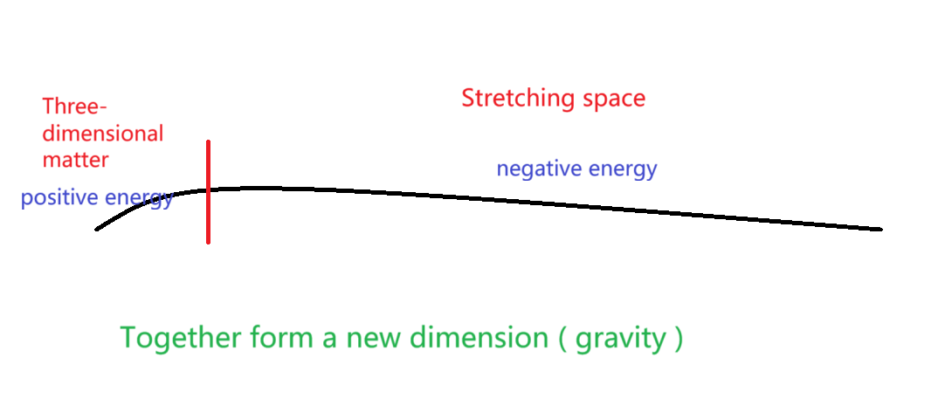

Figure 12

We discuss quantum : the wave function of quantum is caused by collision, collision leads to the increase of dimension, the particle of positive energy is larger, and the wave of negative energy is larger. The general quantum positive energy and negative energy are close to equal ( the residual energy after the last collision produces a new dimension ), that is, the dimension remains unchanged. Now consider a special phenomenon that occurs naturally. We know that the last remaining energy of the collision leads to the generation of new dimensions, but how to know the generation of the next collision ? Perhaps the answer can be found in a special natural phenomenon, such as the mapping of memory and reality in Figure 13. Things that do not exist in the past still produce memories. Although past events do not collide, the remaining energy can still bring memories ( the total amount of energy impact remains unchanged ). Then, the memory that didn 't happen becomes part of an event at some point( the energy forms a collision, which will produce a complete collision in the unit space ). This leads to the dimension can be constantly changing. So how to know when the remaining energy of the collision is generated ? There is also a phenomenon that some substances or events that do not exist in reality can form memories. It can be simply considered as the starting point of the formation of collision residual energy. Although the residual energy of the collision is very weak, it plays a key role in the change of dimension.

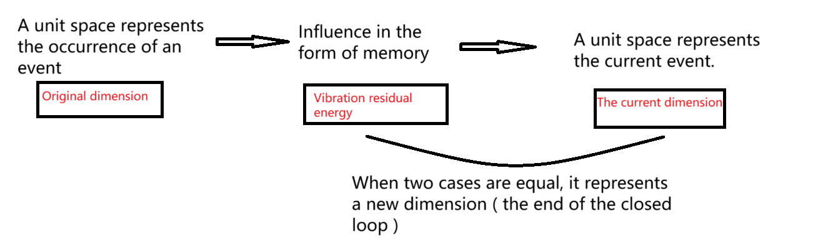

Figure 13

We know that there will be residual energy in the last collision, and this residual energy is also the reason for the static speed of the substance.Therefore, the higher the dimension of the substance ( the premise is not the integer dimension ), the faster the static speed.The residual energy of the collision is generally a positive energy without an event. The positive energy generated by this collision is not balanced by the corresponding negative energy, but the energy generated by this collision will not disappear.That is to say, there is neither an event nor an immediate impact on real substance.But with the accumulation of time will lead to the accumulation of this collision, there is a certain chance to produce their own closed loop.Because different collisions will be different, it is possible to form an energy balance.But this balance is relative and does not produce real events.This closed-loop will be applied to special other events by chance.Instead of a description form : the remaining collisions will gather together until a unit space is formed.This unit space is with energy, and this energy will be possible to achieve energy balance with other substances.With the change of time, this positive energy will be dispersed to the surrounding substance. This dispersion is equivalent to offsetting this imbalance. With the disappearance of these substances, positive energy will gather together again to repeat this process.

Although the remaining energy of the collision is more likely to accumulate on the high-dimensional whole that lacks energy, there may be many high-dimensional parts in a whole. But one thing is sure that the role of collision residual energy is to enhance the dimension, in other words, to promote fairness. Therefore, we can judge that the residual energy of the collision is more likely to accumulate in the high-dimensional part of the low-dimensional whole. Therefore, we can conclude that there is a whole, which is composed of a and b. The dimension of a is higher and the dimension of b is lower. However, for these two as a whole, the high-dimensional part of b is higher than the high-dimensional part of a.

Emphasize how to maintain the stability of the substance, and the difference between positive energy and negative energy will increase the dimension. Only when the positive energy and negative energy are equal can the substance be stable. Due to the balance, the change of dimension is generally divided into two cases. Low and high dimensions are close to the same dimension at the same time. Or two similar dimensions of the small whole, one dimension becomes lower, the other dimension becomes higher. Because there must be energy imbalance between the two sides of the substance, there is generally a high side dimension and a low side dimension, but the overall trend of ascending dimension is fixed ( the general direction is close to the same dimension ). Although the energy of high-dimensional substance is small, the collision energy loss is large. This leads to the higher the dimension, the smaller the mass, but the faster the speed of the object. Therefore, the faster the high-dimensional substance moves, the more obvious the yield of kinetic energy ( heat energy ) is. Now discuss the behavior of substance : the electromagnetic force between two substance is very complex, because with the change of time and distance, the positive and negative energy is not easy to judge. Because the energy distribution of macroscopic substance is not as simple as that in Figure.3. And the energy form of a single substance also changes. Take sleep as an example : any activity during the day can be counted as exercise. Motion can cause objects to collide, so we consider these motions as negative energy. Negative energy can cause substance to reduce the dimension, so at night people will reduce the dimension through sleep. If the negative energy during the day is large, the sleep action at night will increase.

From the previous theoretical experiments, it is concluded that the overall positive energy is greater than the negative energy. Therefore, gravity is greater than repulsion in the universe. Here again explain the reason for the expansion of the universe: Sports will produce collisions，positive energy is larger will lead to substance rising dimension. The extra part of the positive energy in the next dimension is the residual energy after the collision, which will collide under the impetus of time. The extra part of the positive energy in the current dimension is the energy loss in the vibration. For a substance, every collision will lead to an increase in the dimension of the substance. Since there are still only three spatial dimensions after the three-dimensional substance is still static. However, the energy changes ( the essence of gravity is = four-dimensional positive energy - four-dimensional negative energy ). It is a change of space ( there is already another spatial dimension ), because the deformation of space leads to the fact that time is no longer a parameter ( general relativity ). This is why gravity is greater than repulsion, but the universe is still expanding.

If the graviton is included in the particle standard model, the graviton as a three-dimensional boson will certainly produce an infinite number. Because the mass of the graviton is 0, this calculation can obtain two-dimensional fermions to generate three-dimensional gravity. However, gravitons ( we think of gravity ) as unstable high-dimensional substance are difficult to exist in the form of particles, because photons are very close to four-dimensional three-dimensional particles, and gravitons have exceeded four dimensions. In general, it is not the state of particles, which is closer to the shape of waves or strings. The string theory does not start from zero dimension, but from one dimension to describe substance, which is also possible. Four-dimensional photons and one-dimensional strings have one thing in common : for a macro perspective, four-dimensional is similar to a thicker string. It seems that strings can be used to describe higher-dimensional substance, but this behavior is limited. For example, we can only use 1 to 2-dimensional substances to describe 3 to 4-dimensional substances, and the properties of the substances described are limited. Mathematics is a collection of all dimensions, so there can be different ideas for a number, but any single energy in physics exists in a fixed dimension（Mathematics or numbers do not necessarily refer to a certain substance, but can be another substance）. For example, electrons are three-dimensional substances. There may be other dimensions similar to electrons, but there will always be differences that can only be defined as other substances. Just like a three-dimensional substance is indeed composed of countless four-dimensional substance, but we can 't think that one substance can be two substances.The reason why the string theory is partially successful is explained : the string has the same properties of fiber bundles as the two-dimensional substance, and the node of the string is the three-dimensional substance ( because the string has volume, it is a four-dimensional substance ). The energy generated after vibration is also four-dimensional energy, which can be combined into three-dimensional substance. We can imagine dividing the string into countless nodes, each of which can be understood as a three-dimensional point ( three-dimensional substance must be point-like, macroscopic substance cannot be understood as unit energy ). The string is regarded as a four-dimensional substance, and the node of the string can only be a three-dimensional substance. The three-dimensional substance is decomposed into four-dimensional energy as a component of the three-dimensional substance after vibration. Because the reality of three-dimensional substance can indeed be understood as composed of countless four-dimensional substance. The closed string in string theory is similar to the closed loop formed after the three-dimensional substance vibrates into four dimensions, without output or input energy.

The spin of the particle ( three-dimensional ) is determined by the process of collision. The positive and negative energies of the substance with spin of 1 are equal. The substance with spin of 1 / 2 may only have one energy form, and other spin states may also exist ( the development of dimensional balance and collision determines the spin ). Not every environment is dimensionally balanced, but the overall balance of the universe is relatively fixed. Whether Newton 's universal gravitation or general relativity is actually the essence or the microscopic world, the real macro will be very complex due to the complexity of the dimension. The main difference between the magnetic field and the electric field is that the change of the magnetic field depends only on the spatial change and does not depend on the collision ( the energy movement before the collision ). On the contrary, the electric field needs the spatial movement after the collision to produce ( the spatial movement after the collision ). However, there is a special energy periodic transition direction, which is the energy remaining after the collision or the energy that has not yet collided. Because the difference between collision and non-collision is that the energy of collision has determined the direction, and the energy of non-collision will move periodically in three directions once, as shown in Figure 14. It can be imagined that a three-dimensional substance will appear to have a fixed direction, and another zero-dimensional point will move once in the three-dimensional model. In order to achieve the same motion effect, it is necessary to continuously vibrate three times in the three-dimensional model. Since no collision occurs, the spin state of this energy cannot directly determine the type of substance.

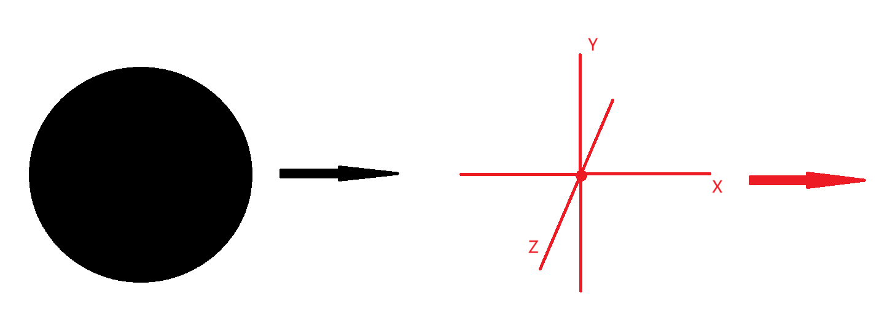

Figure 14

An energy-balanced substance, it should be neutral. However, the unit energy of the constituent substance cannot be neutral energy, and it must be positive energy equal to negative energy. Because any substance is infinitely split into the smallest unit, it is the process of vibration at the zero-dimensional point in Figure 10. This minimum unit is fixed and vibrates non-stop. Therefore, any part of substance is the result of the sum of positive and negative energy. Even if it is neutral, it is also a manifestation of positive and negative energy balance. On the whole, substances with lower dimensions are more likely to obtain negative energy for dimension increase, while substances with higher dimensions are more likely to obtain positive energy for dimension reduction.

As mentioned above, I mentioned that the thinking caused by concentration is to increase the dimension, in order not to mislead me to explain. When we think, we usually focus on our attention and even reach the state of selflessness, because concentration is a kind of positive energy, and the generation of this positive energy is the result of dimension reduction, and the positive energy will produce negative energy. This negative energy is thinking. This negative energy represents that the substance has risen in dimension rather than negative energy to make the substance rise in dimension. Therefore, focusing on the substance to increase the dimension, on the contrary, the relaxation state will lead to the inability to think and will reduce the dimension of the substance. Or divergent thinking is positive energy used to reduce the dimension(Most of life is divergent thinking). The positivity and negativity of energy must also satisfy the most basic principle of reference system. The dimensional balance and positive and negative energy changes we discuss are limited to one whole. For different two substances, we can only find another whole containing two substances in order to better judge the change of energy. However, the remaining energy of the collision cannot form substance, which leads to extreme instability ( but it will be extremely stable under some understanding, because it cannot interact with other substances ), so it is not possible to judge the type of energy by dimensional balance. But we can judge from its nature that this energy has in common is positive energy. ( This energy is very contradictory, it tries to break the basic operating rules of the universe. Although it is still very weak after aggregation, the universe without this energy will die ) and with the improvement of the dimension, this energy seems to be more and more active. I believe that many people are incredible about Lorentz transformation, because mathematics is not as understandable as physics. In fact, the Lorentz transformation is not to keep the speed of light constant, but to keep the negative energy is not greater than the limit value of the positive energy. This premise is not that quality is not negative but time is not negative. The maximum difference between the speeds of the two reference frames cannot be greater than the speed of light c. Consistent with this formula seems to keep c unchanged, in fact, must v < c. Here c is not the speed of light we think but a limit value, so c is the result is not the premise, but the premise is that time can not be negative. Although we can 't give a good formula, I want to explain it roughly : due to the change of energy, the speed of collision changes. The higher the dimension, the smaller the energy but the faster the speed. I think the time inside the substance is the interval of each collision. The faster the energy movement, the faster the collision ? There seems to be no problem statement, but the energy is not exactly equal to the collision, because the number of collisions is fixed. Energy should be the energy carried in the ' ether ', and the speed of the ether is the speed of time. The speed of the ether will have a critical value, then the speed of the ether if less than the critical value can not carry energy. The critical value is c, that is, the time is 0. I don 't think that the speed of motion is greater than the speed of space is the time reversal, and the energy generated later is more forward movement may make the energy from the original space into another space unit. Because energy is transmitted by the ' ether ' to form substance, it is still the future.That is to say, a person may be getting younger and younger, but can 't go back to his youth history. And this change of negative energy increment is likely to be balanced by the powerful laws of the universe, that is to say, extremely unstable. Furthermore, the reason for the change of the space around the substance is that the higher the dimension, the slower the transfer speed of the space around the substance. If we understand the spatial range as the impact of the collision, the spatial transfer velocity can be understood as a range or energy size ( time and surrounding space are similar to the relationship between the electric field and the magnetic field ).

The essence of time is the interval of energy propagation in space. We imagine why time changes : the faster the energy movement in the unit space, the faster the collision speed, but the faster the movement speed, the slower the space propagation speed, and the time does not change. However, we ignore that the collision distance of energy in unit space has changed ( one of the reasons why relativity and quantum theory are difficult to integrate is that the change of integer dimension will directly change the space of unit energy ), and the change of energy speed leads to the change of dimension. The change of dimension directly determines the volume of unit space. Because the propagation speed in the unit space has changed, the total distance of the original energy motion includes the volume of the basic unit space. For example, photons, an integer-dimensional substance, cannot collide because of the equal movement speed of energy and space, and its movement distance is equal to the volume of unit space. What really changes time is the influence of the scale of unit space on the total distance. Total time = collision interval time ( space transfer time ) + substance movement time（The essence of time interval is the change of quantum quantity, but relativity does not consider quantum, only considers large overall substance.）, total distance = unit space length ( space transfer speed ) + energy movement distance. As the dimension increases, the unit space continues to shrink, because the collision interval is equivalent to the speed of time. The higher the dimension, the shorter the collision interval. The coordinate transformation in the Lorentz transformation is that the distance and time of the collision have changed. The reason why the dimension is constantly changing is that the remaining energy of the collision excites the unit energy to collide in another dimension. The remaining energy of the collision is also the cause of gravity, but the remaining energy of the collision is not gravity, but the power that can generate gravity. There is also a misunderstanding that the two-dimensional surface vibrates into a three-dimensional ball, which means that the three-dimensional is composed of two dimensions. On the contrary, after the vibration, the original two-dimensional will change in dimension, so the two-dimensional substance is composed of countless three-dimensional substances. That is, countless three-dimensional spheres form a curved surface shape ( why the field exists in all spaces : the unexcited space is still a part of the two-dimensional field, when all the spaces in the two-dimensional field become three-dimensional substance, there is no unexcited field ). Here is a key point : why quantum fields can accommodate many physical phenomena. This understanding does not conflict with Figure 8. It is correct that three-dimensional substance is evolved from two-dimensional substance and two-dimensional substance is composed of three-dimensional substance.

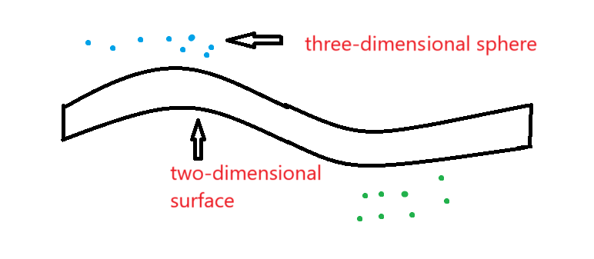

Figure 15

It is difficult for a macroscopic substance to reach the energy distribution in Figure.3. Because this situation only exists in the integer dimension substance, that is to say, the positive energy is equal to the negative energy and cannot collide to cause energy transfer. The energy distribution of most macroscopic substances is very complex ( but not completely chaotic, because the positive and negative energy has a specific direction, which is similar to the distribution in Figure.8 ).Suppose that the matter is composed of a and b, and the dimensions of a and b are determined by the energy distribution. For example, if a has more positive energy, the lower the dimension of a, the higher the dimension of b, and the two substances reach the dimensional balance. There are two possibilities now. In order to increase the dimension, a is easier to get the negative energy of b. In this case, the overall dimension of this substance continues to increase until it is decomposed into more substances in the next dimension, which is also a normal phenomenon. The other is that a will also get the positive energy of b, that is, the overall dimension reduction of matter. If this happens all the time, there will be a big collision, re-ascending the dimension ( The first case always happens and may be wrapped up ). Although energy will appear alternately between the increase of dimension and the decrease of dimension, the continuous increase of dimension as a whole cannot be changed.

Why the basic particles are fixed and limited, the summary is that the change of dimension will not change the basic energy properties. For example, after the two-dimensional field excitation or collision changes the dimension, it will only change the number of excited particles. However, the type of elementary particles does not change ( here does not consider the different processes caused by different vibration directions, does not define the same time only to maintain the results ), and the original field only changes the number of basic units does not change the energy of each unit. Therefore, the basic unit remains unchanged, but the dimension changes, and the total energy may only change slightly ( because the anti-energy will also excite the basic particles ). Therefore, the only reason that really determines the type and number of basic particles is the number and dimension of the force and the corresponding new dimension. At the same time, these basic particles also determine that the type of force is limited. Because only the force of the number of basic particles is changed, and the type is not changed. However, this does not mean that the dimension can not be changed, because the basic components of any dimension are the zero-dimensional points that collide in the unit space, and only the number of zero-dimensional points is changed. Therefore, different kinds of energy can form a new dimension as long as they can achieve dimensional balance.

Although the remaining energy of the collision is positive energy, the direction of the vibration is not the same, because the remaining energy of the collision comes from a lot of energy ( excitation : when the two-dimensional field is excited, it can only be excited in an independent unit space, because the energy is not large enough to make the two-dimensional substance directly vibrate into a three-dimensional substance, but the basic unit is excited into a three-dimensional substance and the original two-dimensional substance can form a non-integer dimension substance ). As a result, complex energy clusters will be generated when the remaining energy is aggregated ( complex energy clusters do not change their own dimensions, and the result is still to generate the next dimension of energy. However, the time spent in the process is chaotic ), but in the end it is still dimensionally balanced. Why the residual energy of the collision must be positive energy, because the accumulation of the residual energy of the collision is to cause a new collision of the substance to occur again, and only after the accumulation can we observe. This collision must not be in the original dimension ( energy is not enough to make the original dimension unit energy collide, can only make the unit dimension energy collide to another dimension ), the direction of the first collision is positive energy. Because the positive direction is the direction of the first collision we defined, the positive and negative energy of each dimension is also relative. Just because the positive direction represents the energy of contraction, there is no difference between the two energies.

The improvement of dimension should be a very slow process, but in the whole of achieving dimension balance, part of the structure can be rapidly increased, and the other part can be rapidly reduced.

Assume that there is a four-dimensional substance as shown in Figure 15, the length of the four-dimensional wave is a, and the side is expressed as b. Why do I think that the three spatial dimensions and one time dimension of general relativity can be equal to the four spatial dimensions in quantum theory. Because the fourth dimension of substance is similar to a wave ( of course, it cannot be linear ). And when the four-dimensional substance is formed, these four dimensions do not exist before and after, because it is simultaneous vibration. However, there will be a length gap, because we observe the four-dimensional from a three-dimensional perspective, which will have the influence of the reference frame, resulting in the movement of the first three directions can not be seen. Here we can understand that a is the fourth dimension, and b is the first three dimensions. The four-dimensional substance velocity ( a direction ) does not change the length of the first three dimensions. However, the change in speed affects the dimension and can change the length of the fourth dimension. I also said before that speed is related to time, the faster the speed, the slower the time. That is to say, the change of four-dimensional wave motion is equivalent to changing the time of each dimension without changing the first three dimensions. Conversely, if I think that a is the first three dimensions, b is the fourth dimension, then the speed of the four-dimensional movement changes the length of the first three dimensions, and the fourth dimension remains unchanged. That is, time-invariant space changes. Finally, it is concluded that the key to solving relativity and quantum mechanics lies in time, speed affects dimension, and dimension affects time. In quantum mechanics, the change of time can be transformed into the change of total amount ( total amount refers to the total number of quantum or the total number of zero-dimensional points ), because the change of time is essentially the change of dimension, which determines the speed and the total amount of zero-dimensional points. In relativity, the comparison between the whole and the whole is generally discussed. If the total amount of zero-dimensional points changes, it can be considered that the original whole has changed, and the material has changed from one substance to another. But if it is compared with another whole, it can be considered that time has changed.

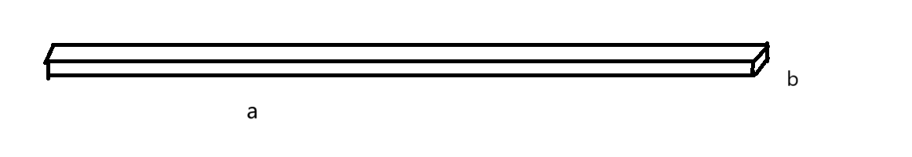

Figure 16

A kind of energy a is defined as positive energy. Actively generated energy a and passively generated energy a may be completely opposite to the change of dimension. Passive generation is to achieve the dimensional balance of the substance itself, which will not change the nature of energy a. However, the active generation may be to achieve a new overall dimension balance under the influence of the surrounding environment. That is, the difference in integrity will also affect the positive and negative nature of energy.

It is assumed that there are substance a and substance b ( the energy form is completely random ), and there is a chance to form a dimensional balance when the two substances are in contact and coexist for a long time. One of the two substances is positive energy and the other is negative energy. Although stable, the two substances are in collision with each other. The essence of mutual attraction between positive and negative may be to seek stability through collision, and the essence of same-sex repulsion may be to accelerate the destruction of stability and move in the opposite direction. Explain the relationship between special positive energy and negative energy : for general positive energy, negative energy can indeed be generated to achieve dimensional balance. For example, self-confidence is a kind of positive energy ( may also be a collection of energy ), is an important part of human dimension. But not all self-confidence can reach the dimension. When we define an energy type, we should not only follow the name and composition of energy, but also consider the location of energy in time and space. For a longer motion space, the positive energy at some moments will move in the direction of stronger positive energy. For example, a little thought and very thought may be the same kind of energy, but the results are completely opposite. A little want to show that there will be no collision, but will move in the same direction. And very much want to collision may happen soon, is about to rebound dimensional balance, move in the opposite direction.

The formation and dissipation of the remaining energy and memory are similar, but no extra substance is formed. This energy is stored information and algorithms, does not affect the information. With the increase of information and algorithms, the dimension of information changes more and more complex. Suddenly a part of the dimension rises in the big whole and this situation often occurs. Because the dimension balance will lead to the complexity of the dimension combination in the whole, the general situation is that the low dimension produces the fixed direction of the high dimension, but due to the collision residual energy, there will be a situation where the high dimension is first generated and then the low dimension is driven, as shown in Figure17. In this way, we can express the different views of artificial intelligence. Generally, we think that the reason why AI is not conscious is the lack of ' self-consciousness ', but according to my understanding of computers, I think AI is like collision residual energy（The algorithm is a method of dimension change, and the control algorithm is the residual energy of the collision, but the residual energy of the collision needs the previous vibration direction to work）. That is to say, AI may be an immature consciousness, but AI has no dimensional substance that can be balanced. Human imagination cannot be separated from the real world. The human brain needs to balance the body and the surrounding environment ( because the body is the previous dimension of the brain ), but AI cannot find its carrier. The machine we usually think of is not the carrier of AI ( not the whole ). Therefore, the carrier of AI should include the human brain that designs AI. This may be a future trend or a new thing instead of the old thing. Because with the increasing power of AI, the brain 's collision residue seems to slowly disappear ( probably not related to AI, but the previous collision residue automatically dissipates ). That is to say, it may be the coexistence of human and AI in the future. This is not sad, perhaps AI can form a dimensional balance with the brain to make the brain dimension, but this is not a short time can be formed.

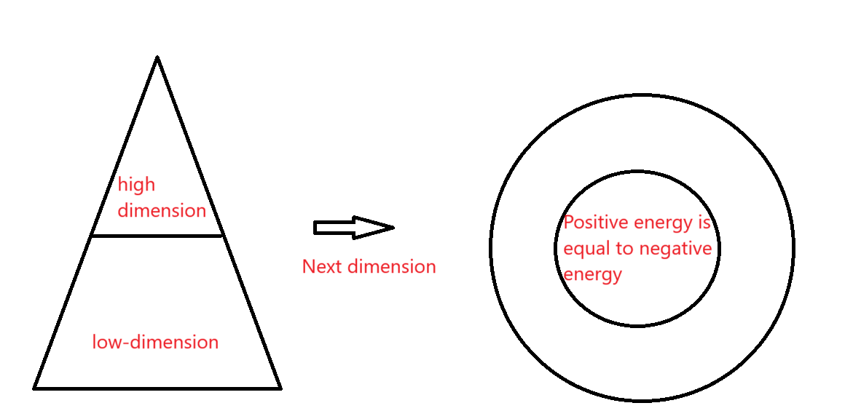

Figure 17

First of all, race and country are two different wholes, and the dimension comparison between countries cannot be judged only by the difference of race. Don 't want to bring more misunderstanding. For the country, ordinary people are the lower side of the dimension（Of course, because Figure 2 is not all ordinary people. It is also related to the collision mode. Similar to the rich and the rich second generation, the rich will get more negative energy. However, the overall probability of the rich and the second generation of the rich is entirety with more negative energy.）. I think that maybe the dimension of the yellow people is slightly higher ( in some ways ), and the yellow people prefer to think to reduce the dimension. It is obvious that the average IQ of yellow people is higher, but the wisdom is not much. I explain the reason from the analysis of strength : yellow people love to use strength ( negative energy ) to lead to good endurance ( positive energy ), good endurance leads to low explosive power ( negative energy ). The difference between people is very small, and the total amount of positive and negative energy is almost the same. If a person doesn 't like to think at ordinary times, but encounters difficult problems, then he is likely to gain more wisdom than the person who loves to think at ordinary times. Or this person has greater wisdom in other ways. So many geniuses usually look ' not very smart '. Of course, if you don 't think all the time, it may also be that the energy in this direction is too weak ( but this also means that the energy in other directions is strong ). Because the collision residual energy can produce many complex collision directions, but the basic physical laws and positive and negative oppositions will not change.

A simple analysis of the different dimensions brought about by different genders : the higher the dimension, the more negative energy it is easier to get positive energy to reduce the dimension ( which does not conflict with the previous article, here refers to the process of dimension reduction, the previous article refers to the prerequisite for dimension reduction ). The lower dimension has more positive energy, and it is more likely to have negative energy to increase the dimension. Women should be the higher dimension side, and men are the lower dimension side. However, the dimension does not completely determine the positive and negative, because from Figure 3 and Figure 4, we can know that a substance contains two forms of energy. And this does not mean that the first vibration direction of the universe is negative, because all the whole is more positive energy, and the positive and negative difference is only based on the whole as the reference system. The first collision of the universe includes the energy of the first collision of each independent whole. The energy of the first collision does not come from the whole, but from the outside, that is, the energy generated in the first positive direction gives the whole rather than the part of the dimension increase. With the balance of dimensions, two different positive and negative energies of the whole are produced. When calculating the positive and negative energy, we should consider the difference between Figure 3 and Figure 4.For example, a large number of women do not want to huddle together to communicate, but three or two women can become friends.

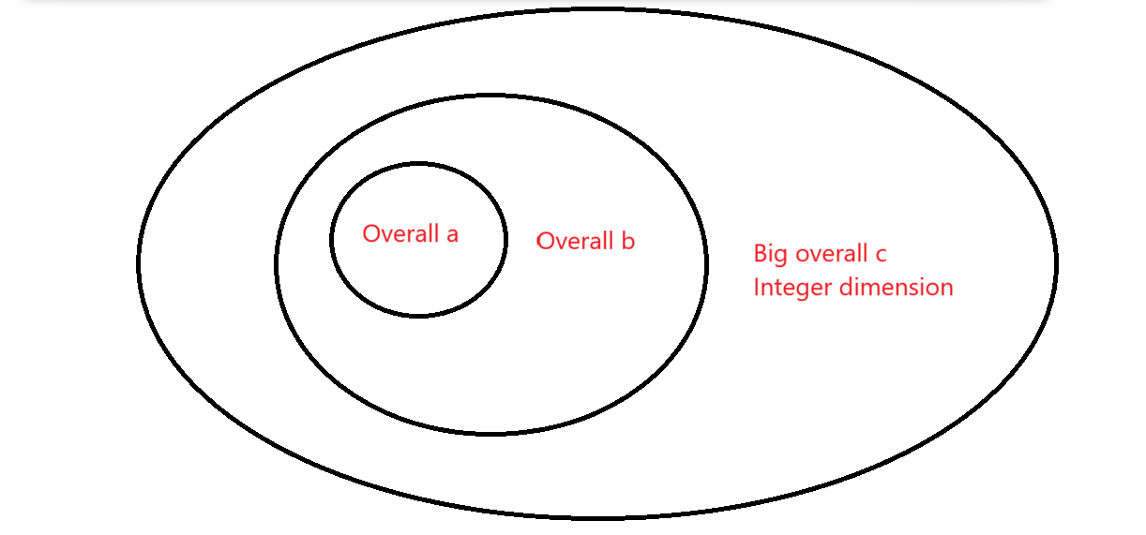

Figure 18

Due to complexity : I think that the big whole is the micro, the small whole is the macro. Since positive energy represents aggregation and negative energy represents dispersion, the gas dimension is higher than the liquid dimension, and the liquid dimension is higher than the solid dimension ( not absolute ).

The world brought to us by the digital age is a complete substanceism, but in reality, there may be some parts that cannot constitute substance but do exist. Our imagination seems to be non-existent in the real world, but imagination is the energy in the universe, and we can 't see it. Or there are many people think that ' God ' exists, the reason is that God ' manifest ', but we have not been able to find. There are many similar things. These energies are also a kind of meaning opposite to the real substance world. Therefore, it is possible to believe that ' God ' can exist in the real ' God '. But these energies are still relatively weak.

Usually we think that for the same whole or structure, we will have different answers from different perspectives, so we think that the answer of this whole is not unique. However, it is possible that the truth is a small whole of different dimensions of the whole, that is to say, we can observe the dimensional distribution of the same material from different angles. Because the general whole, including the current universe, is not completely equal in positive and negative energy ( all angular dimensions are equal ). Such a whole will have a complex dimension balance, and the observation behavior can be considered to form a dimension balance between the two wholes. So we can think that the observation behavior is an energy effect. For us, human observation behavior leads us to be in the alternation of dimension increase and dimension reduction ( overall dimension increase ). This phenomenon leads to that all parts of the universe will not develop alone, but a perfect chaotic state. In order to achieve this ideal dimensional balance, the universe must have boundaries and infinite zero-dimensional points.

Dimensions can be reduced through diet, and vegetables and lean meat may be a good choice. In a person 's life, we can feel that the body is reducing the dimension, but not all parts are reducing the dimension, and a large whole cannot change too many dimensions in a short time. People with high dimensions may have low national dimensions, and different things cannot be confused. Or smart people love to think, but the smartest people may not be the most thinking people. Smart people are kinder but a little smart people may not be kind ( not enough to hit the balance ). The description of the small whole still cannot rely too much on the basic theorem. The judgment of positive and negative energy can not rely too much on feeling. These descriptions only provide inspiration, the real process is very complex, not a simple basic theorem can be explained.

# **14 Acknowledgments**

**I express my sincere gratitude to all the individuals who provided assistance and support during the course of my research. It is my aspiration that my paper will be of assistance to a wider audience.**

**15 References**

[1]“Relativity theory.” An Einstein Encyclopedia, 31 Dec. 2015, pp. 208–216, <https://doi.org/10.1515/9781400873364-036.>

[2]“Newton and the law of Gravitation.” Pioneers of Science, 28 June 2012, pp. 180–202, <https://doi.org/10.1017/cbo9781139380904.010.>

[3]“Lagrange and laplace—the stability of the solar system, and the nebular hypothesis.” Pioneers of Science, 28 June 2012, pp. 254–272, <https://doi.org/10.1017/cbo9781139380904.013.>

[4]“From classical mechanics to Quantum Mechanics.” Quantum Mechanics, 16 Apr. 2009, pp. 7–42, <https://doi.org/10.1017/cbo9780511813955.002.>

[5]“Gravitational waves, theory and experiment (an overview).” Gravitational Waves, 29 Jan. 2001, pp. 15–28, <https://doi.org/10.1201/9781420034257-3.>

[6]“The Riemann hypothesis.” The Riemann Hypothesis, pp. 41–58, <https://doi.org/10.5948/9780883859896.006.>

[7]“Antisubstance.” Paul Dirac, 12 Feb. 1998, pp. 46–87, <https://doi.org/10.1017/cbo9780511564314.004.>

[8]Bambi C ,Dolgov A ,Freese K .A black hole conjecture and rare decays in theories with low scale gravity[J].Nuclear Physics, Section B,2006,763(1):91-114.

[9]Unveiling the edge of time: black holes, white holes, wormholes[J].Choice Reviews Online,1993,30(07):30-3810.

**16 Figure legends:**



Figure 1: Space shape.



Figure 2:The process of spatial shape change.



Figure 3: The positive energy is the central repulsive force, and the surrounding gravitational force is negatively charged.



Figure 4: Negative energy is the repulsive force around the central attraction and is positively charged.



Figure 5: Two-slit interference experiment.



Figure 6: The space formed by the intersection of magnetic and electric fields.



Figure 7: When two objects of the same mass collide, the greater the difference in momentum is, the closer the number of collisions is to the π.



Figure 8:The relationship between dimensionalitys is that the higher dimensionalitys have a larger range but infinitely small energy, the lower dimensionalitys are faster, and the lower dimensionalitys produce more dimensionalitys.



Figure 9:A two-dimensionalityal substance



Figure 10:The generation of positive and negative energy



Figure 11：Balance of two substance dimensions



Figure 12：Together form a new dimension ( gravity )



Figure 13：A special phenomenon occurring naturally.



Figure 14



Figure 15



Figure 16



